Travel Group 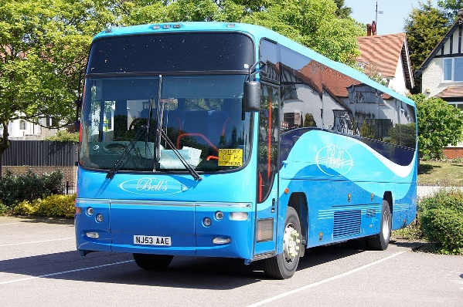
Roland Higgins, 5 Roman Mill Gardens, Stamford PE9 1GB
Mobile: 07903 420154 Email vjrmhiggins@hotmail.com
Belvoir Castle & Gardens 11th June 2025 - £43.00*
*Includes Castle & Gardens admission and tour (normally costing £29)
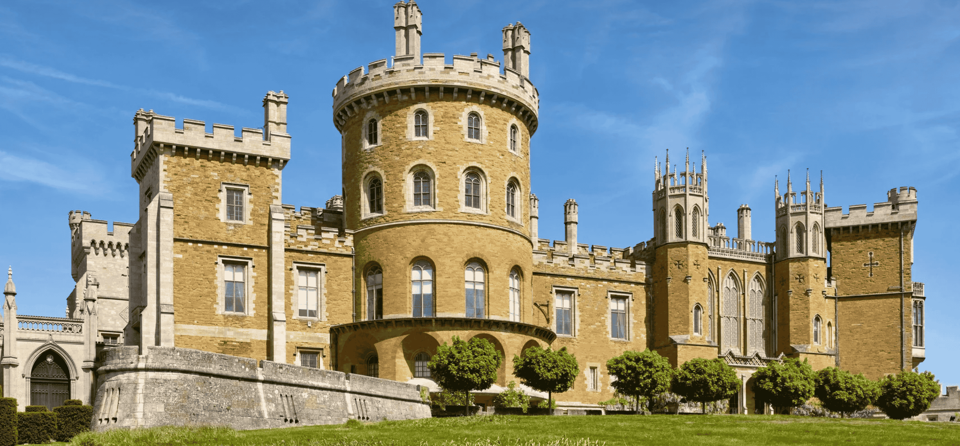
This trip is to a famous destination which is almost local and yet is tantalisingly hard to reach. Belvoir Castle has been the backdrop to so many films and dramas including The Crown, The Young Victoria and Victoria & Abdul. We have booked tours so you get the best information and stories about the magnificent State Rooms. The guides will talk about the centuries of history, art, and royal heritage which come together in stunning architectural and decorative displays. The Castle houses an impressive collection of artworks, including paintings by renowned artists. The rooms have historic furniture, and priceless artifacts that tell the story of British aristocratic life through the centuries.
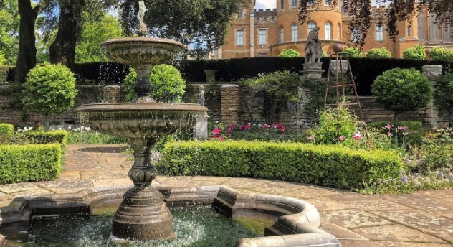
You will also have ample time to visit the beautiful gardens which include formal gardens and woodland walks. You can also visit the retail village offering everything from fresh local produce to luxury fashion, homewares, and garden essentials.

……………………………………………………………………………………………………………………………………………………
Name(s) please give name of each passenger you are booking for ……………………………………………… ..
………………………….. Phone no……………………………………… Email ……………………………………………………….
I/We enclose a cheque payable to Stamford u3a for £43.00 or a direct credit will be made to Stamford u3a’s account no. 00655135 at Lloyds Bank, Sort Code 30-98-02, stating name and reference Belvoir (e.g. Roland would use Higginsbelvoir), or contactless card payment at meetings. I/We wish to be picked up at: □ Stamford Bus Station (09.00) □ The Danish Invader (09.15)

